EXPNO 9: CREATE A SNAPSHOT OF A VM AND TEST IT BY LOADING THE PREVIOUS VERSION/CLONED VM
AIM:
To create a snapshot of a vm and test it by loading the previous version/cloned vm

PROCEDURE:
STEP 1: GOTO VMWARE WORKSTATION. STEP 2: CREATE FILES ON DESKTOP.
STEP 3: CLICK ON VM AND SELECTS SNAPSHOT-> TAKE SNAPSHOT.
STEP 4: SNAPSHOT IS BEING DONE

IMPLEMENTATION

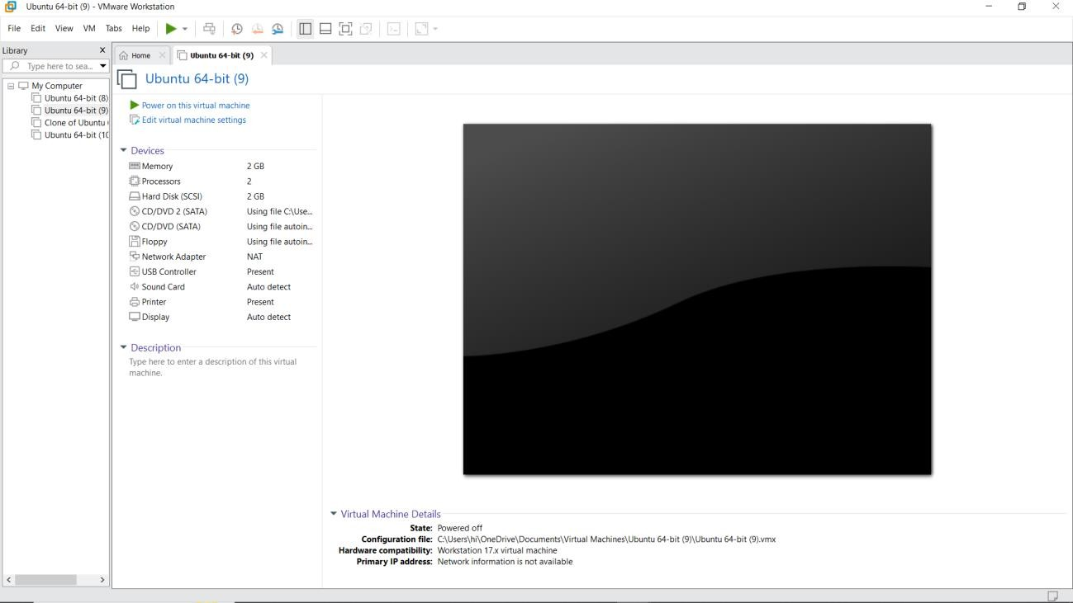

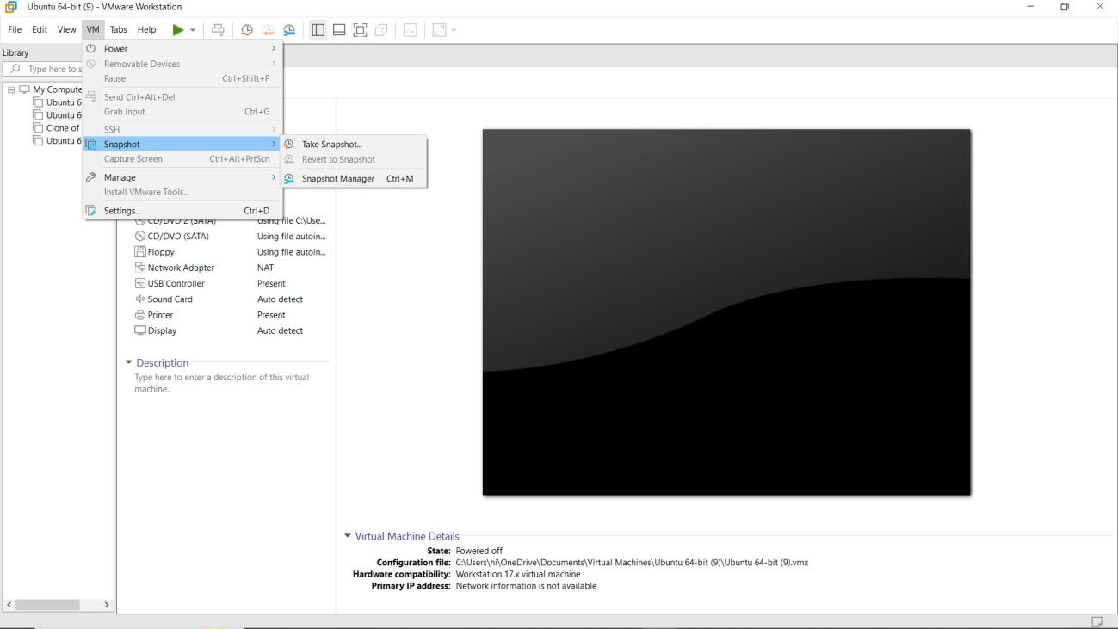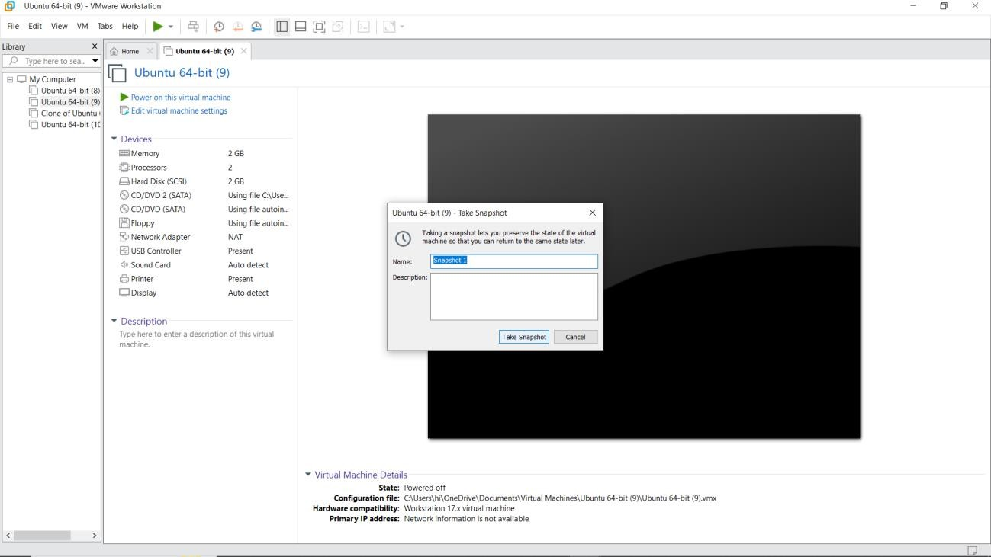

RESULT:
A snapshot of a vm and test it by loading the previous version/cloned vm has been created.

